INGLÊS - ELEMENTARY III (Activities week 3 – June 2020)
_______________________________________________________________________

Learn/Practice English with MOVIES (Lesson #7) Title: Madagascar
https://www.youtube.com/watch?v=14Lllyj3q3I

Learn the difference between sensible and sensitive
https://www.youtube.com/watch?v=ZPRBv-UfzQM

_____________________________________________________________________

The Origin of St Valentine´s Day

Click on the following link to watch the video and answer the following questions:
https://www.youtube.com/watch?time_continue=10&v=QWzEL_brPvo&feature=emb_logo

Q. 1 Fill in the blanks.

"Ah, love! Well, it might not be what makes the go , it is what make the worthwhile. Maybe that’s
why billions of people throughout the centuries have seen fit to an entire to grand gestures of with
Valentine’s Day, the only holiday best celebrated in ."

Q. 2 True or False? Choose the correct quotation to justify your answer!

a. We don’t know for sure where the tradition of Valentine’s Day comes from. True. False.

b. Valentine’s Day contains vestiges of the early Christian Church and Ancient Greece. True. False.

Q. 3 The association between mid-February and romance goes back to a pagan festival known as Lupercalia, likely
honouring either Lupa or Faunus. Who were Lupa and Faunus?

Luppa was the of Rome who suckled and .

Faunus was the .

Q. 4 How did the festivities begin?

The festivities began with , then the ritualistic slapping of with
to bestow (~ to give) for the coming year.

Q. 5 In an effort to christianise the pagan festival, Pope Gelasius declared February 14th as St Valentine’s day in …

the 3rd century. the 4th century. the 5th century. the 6th century.

Q. 6 There were several St Valentines. One lived during the 3rd century AD under Emperor Claudius II. Who was he exactly?

a valiant soldier. a defiant Roman Priest. a famous doctor.

Q. 7 Fill in the blanks.

Claudius was an ruler. His battles required vast armies of men to for long periods of time,
resulting in a military that was and . So was Claudius to stop love from sapping the will of
his armies, he banned all together.

Q. 8 What was Father Valentine’s reaction?

Father Valentine thought the ban and he continued to .

Q. 9 What happened to Father Valentine in the end?

In the end Father Valentine was and .

Q. 10 Who did Father Valentine fall in love with?

Father Valentine fell in love with his jailer's .

Q. 11 Why is February 14 a special date?

February 14 corresponds to the day .

getting retailers plenty to love as well.

ANSWERS:
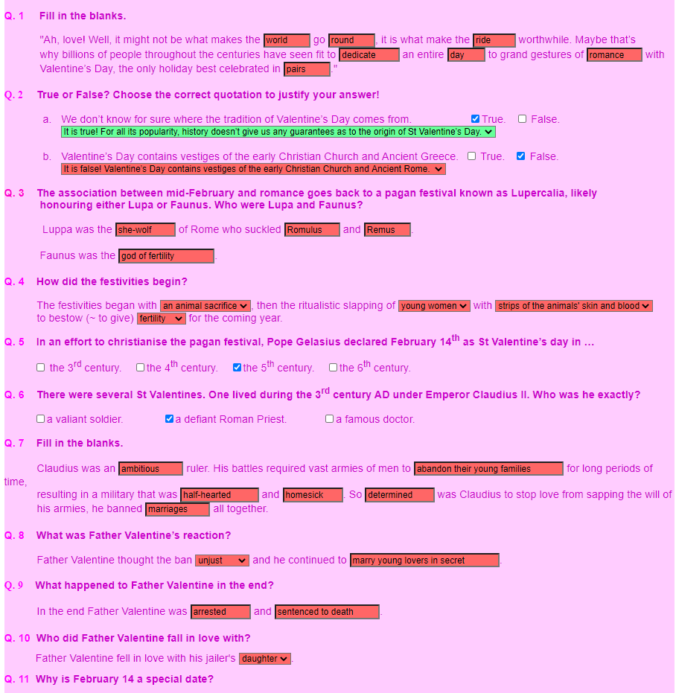
____________________________________________________________________

St Valentine's Day
ACTIVITY 1: Match the words with the pictures.

a bow and arrow - a valentine (card) - chocolates - a couple - Cupid - an engagement ring - a bunch of flowers - a heart -

to hug - to kiss - lovers - perfume and jewels - a present / a gift - to propose - a romantic dinner - a sweetheart.

ANSWERS:
Chocolates – perfume and jewels – a heart – a romantic dinner – to hug – a valentine card - a bow and arrow – to kiss – a bunch of flowers – lovers – cupid – a present (a gift) – a couple – a sweetheart - An engagement ring – to propose

Let’s learn the future with BE GOING TO

Entre as diversas formas de indicar o futuro em inglês, utilizamos a estrutura BE + GOING TO + VERB para indicar:
1. Previsões baseadas em evidências, sobre algum evento futuro. Temos certeza que algo acontecerá.
Look at those clouds! It‘s going to rain this afternoon. [Olhe aquelas nuvens! Vai chover hoje à tarde.]
That car is going to hit the wall. [Aquele carro vai bater no muro.]
2. Intenções, planos (note que as decisões já foram tomadas).
I‘m going (to go) to France next month. [Irei à França no próximo mês.]
He is going to graduate in December. [Ele vai se formar em dezembro.]
They are going to discuss this topic. [Eles discutirão esse assunto.]

Futuro (be going to) negativo
futuro  simples | forma  contraída | significado
I  am  not going to work. | I’m  not going to work. | Eu  não trabalharei
You  are  not going to work. | You  aren’t  going  to work. | Você  não trabalhará
He  is  not going to work. | He  isn’t  going to work. | Ele  não trabalhará
She  is  not going to work. | She  isn’t  going to work. | Ela  não trabalhará
It  is  not going to work. | It  isn’t  going to work. | Ele/Ela  não trabalhará
We  are  not  going to work. | We  aren’t  going to work. | Nós  não trabalharemos.
You  are  not going to  work. | You  aren’t  going to  work. | Vocês  não trabalharão.
They  are  not going to work. | They  aren’t  going to work. | Eles  não trabalharão

I am not going to buy new pants next week.
They aren’t going to play soccer in the winter.
We‘re not going to be here tomorrow.

Futuro (be going to) interrogativo
futuro  simples | significado | short  answer
Am  I  going to work? | Eu  trabalharei? | Yes,  I am.  No,  I’m not.
Are  you  going to work? | Você  trabalhará? | Yes,  you are.  No,  you aren’t.
Is  he  going  to work? | Ele  trabalhará? | Yes,  he is.  No,  he isn’t.
Is  she  going to work? | Ela  trabalhará? | Yes,  she is.  No,  she isn’t.
Is  it going  to work? | Ele/Ela  trabalhará? | Yes,  it is.  No,  it isn’t.
Are  we  going to work? | Nós  trabalharemos? | Yes,  we are.  No,  aren’t.
Are  you going  to  work? | Vocês  trabalharão? | Yes,  you are.  No,  you aren’t.
Are  they going  to work? | Eles  trabalharão? | Yes,  they are.  No,  they aren’t.

Are you going to study English this weekend?
Is Allyson going to get married this year?

______________________________________________________________________

Click on the link to do the exercises:
https://www.inglesonline.com.br/exercicios-de-ingles/presente-continuo-com-significado-futuro/
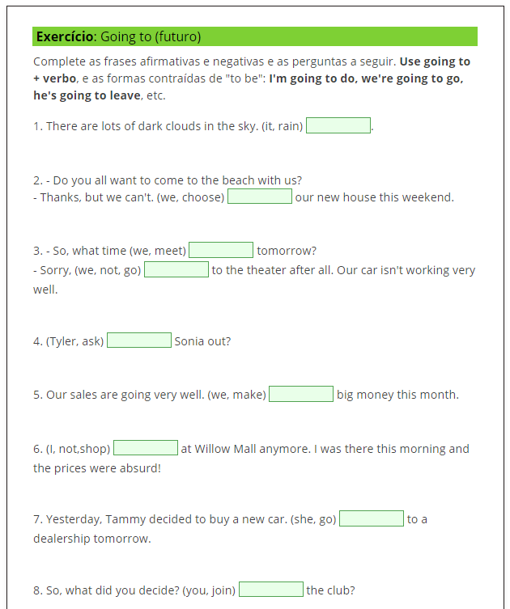

ANSWER KEY:
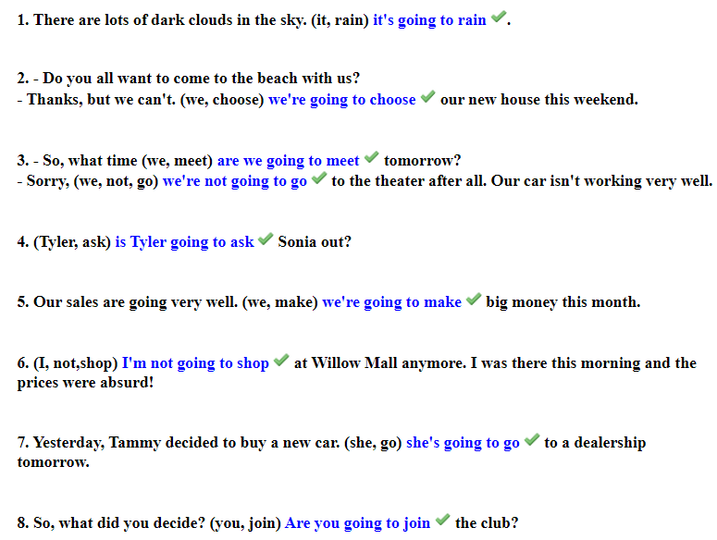

_____________________________________________________________

Click on the link to do the exercises:

https://www.inglesonline.com.br/exercicios-de-ingles/presente-continuo-significado-futuro-2/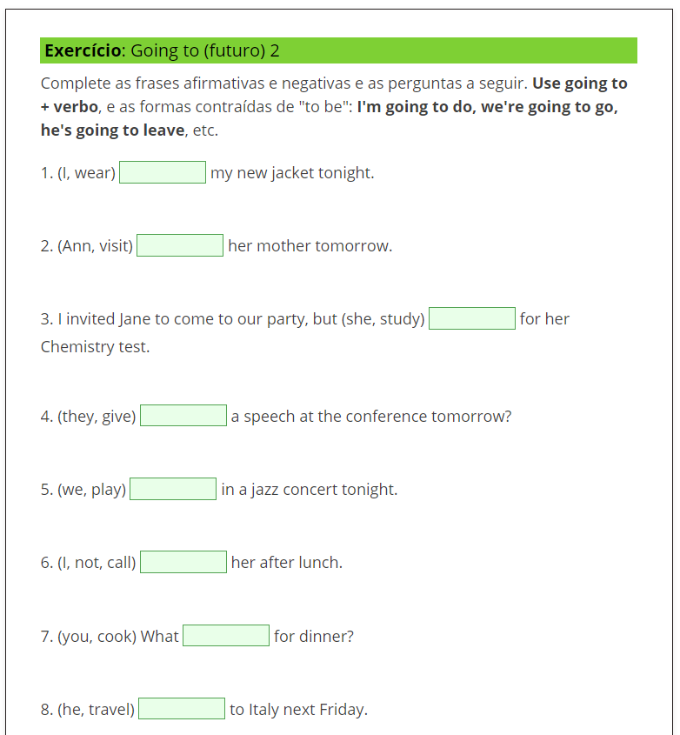

ANSWER KEY:
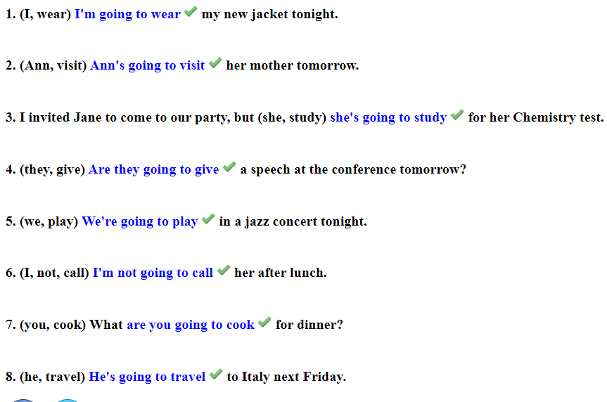

Kátia Vecchi – kcjvecchi@uem.com

