1) Read the text and fill the gaps with these words:
UPPER-INTERMEDIATE II - EXTRA ACTIVITIES
Teacher: Milena Alonso – mpoalonso@uem.br
NAME:_________________________________________________ GROUP:__________________

AIR TRAVEL – POSITIVE AND NEGATIVE SIDES
company disadvantages cost relax decide luggage worth attacks savings headache people

Flying makes travel to faraway destinations more practical, but there are also some ______________________________. When we make a decision to drive or fly it will depend on the trip, including the distance and route. When planning our next business or holiday trip, we can weigh the positive and negative sides of flying which can help us____________________.
In the first place, flying shortens the travel time to our destination. A plane travels much faster than a car or a train. The farther we travel, the time ________________________ become more significant. If we are only flying to the next country, we won't save much time. A longer trip can be shortened, what would be days in the car to just one day of travel on a plane.
One positive side is also that the airline ________________________ makes the work for us. They load our luggage and get us from our departure city to our destination. We can just sit in our seat and ___________________ instead of worrying about traffic, directions, weather, we don't have to be careful on the road etc.
On the other side, the airport can give us a_____________________ . Very often there are long lines at ticket counters, the checkpoint often asks travellers to arrive at the airport at least two hours before the plane departs. Over the last years, because of the terrorist’s ____________________ , there have been high security measures which mean we must walk through special scanners or have a check from a security agent. Another problem in large airports is that travellers often need to get from one gate to another in a different part of the airport in a very short time. And there is also a problem of lost ______________________ .
Cost is often another negative side of air travel, but the impact depends on how many ________________ are traveling and how far we are traveling. Each extra traveller for air flight increases the cost significantly because we're paying for another ticket. For long distances that take multiple days to drive, the ____________ of flying may not be too much higher. The drive would include a large fuel cost, hotel costs and meals on the road. If we're traveling alone, the cost of one airline ticket for the long distance is probably less than the car travel costs. Even if flying by plane costs more than driving in a car, the convenience and time savings is ______________ it.
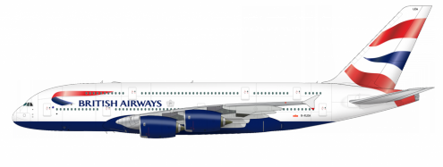

2) Complete the text on the right with the PAST TENSE forms of the verbs on the left.

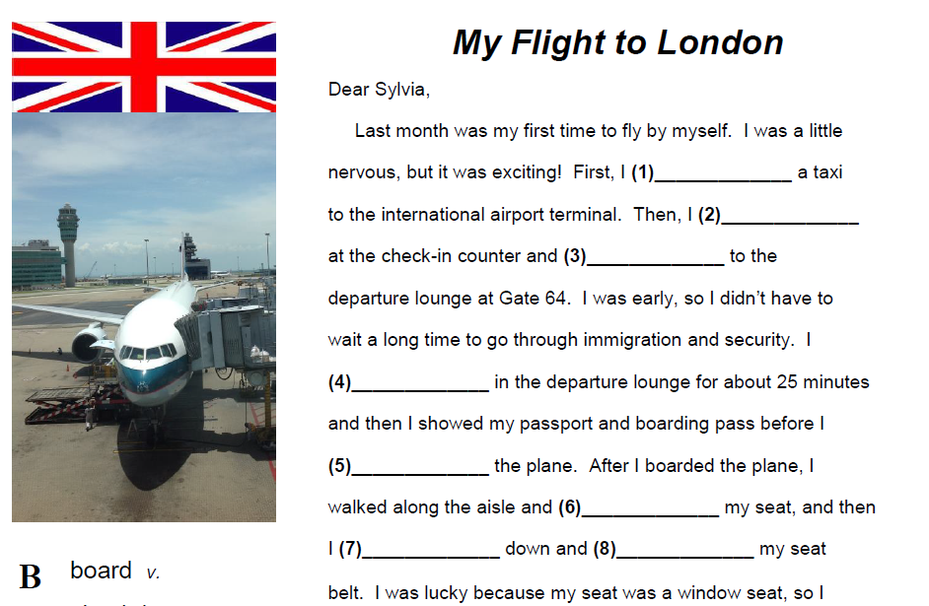
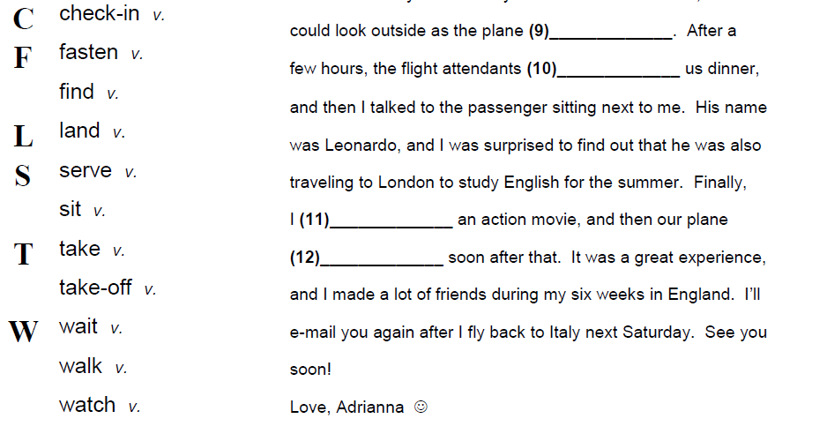

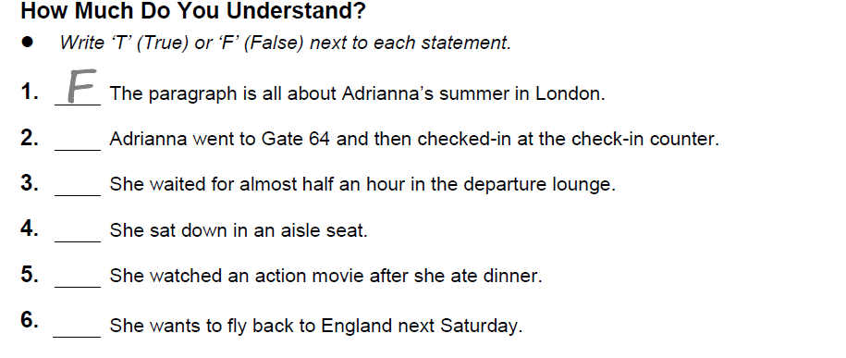
3) Look at the Departure table below. Then, listen, complete, and decide if the statements are true or false.
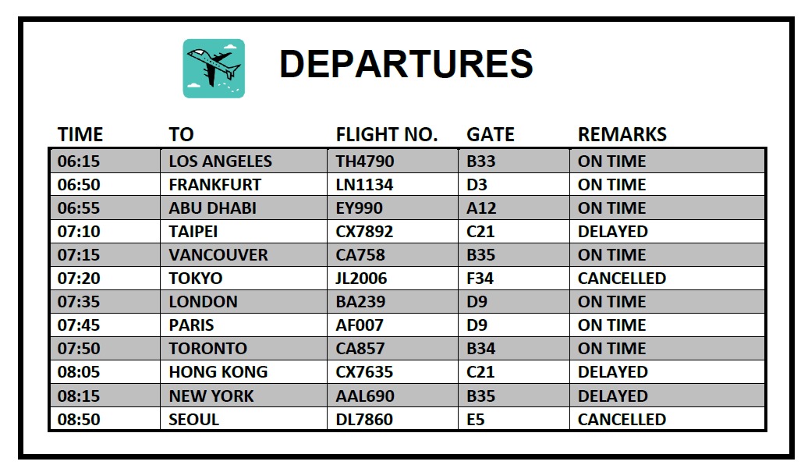

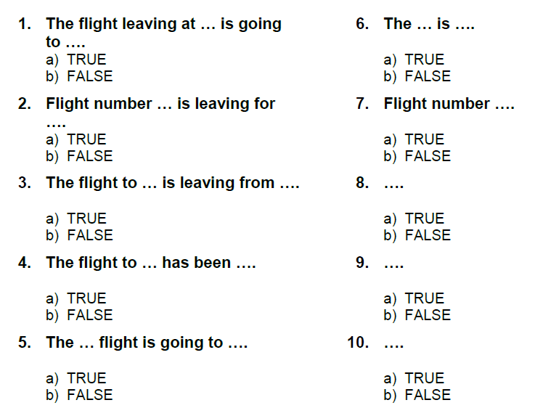

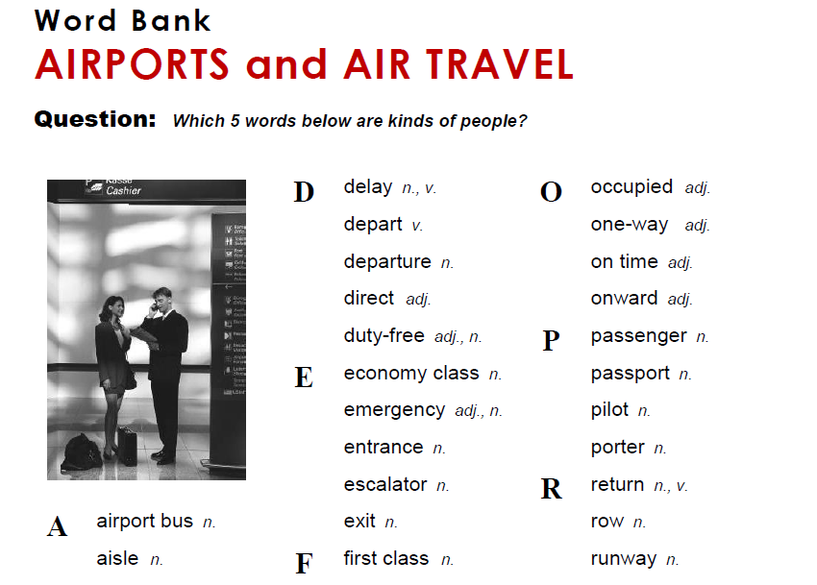
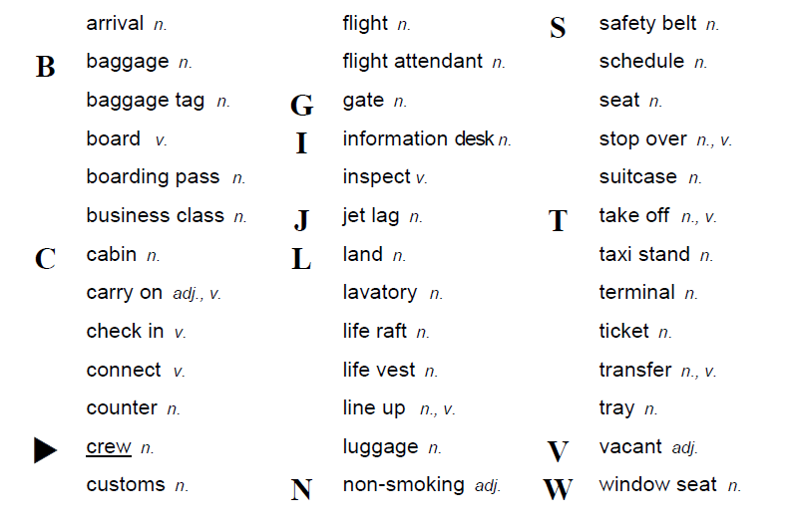
ANSWER KEY:
Exercise 1

disadvantages
decide
savings
company
relax
headache
attacks
luggage
people
cost
worth

Exercise 2
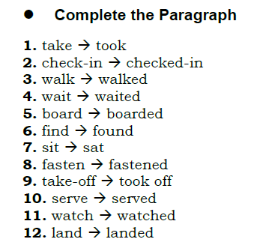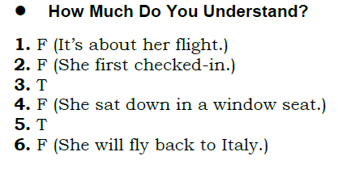
Exercise 3
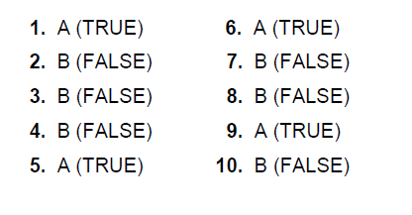
Wordbank:

crew flight attendant passenger pilot porter

Please send a copy of the exercises to the teacher´s e-mail. Hope you enjoy guys!

